Statistics CA Test D00255640

Q1
This code returned this output:
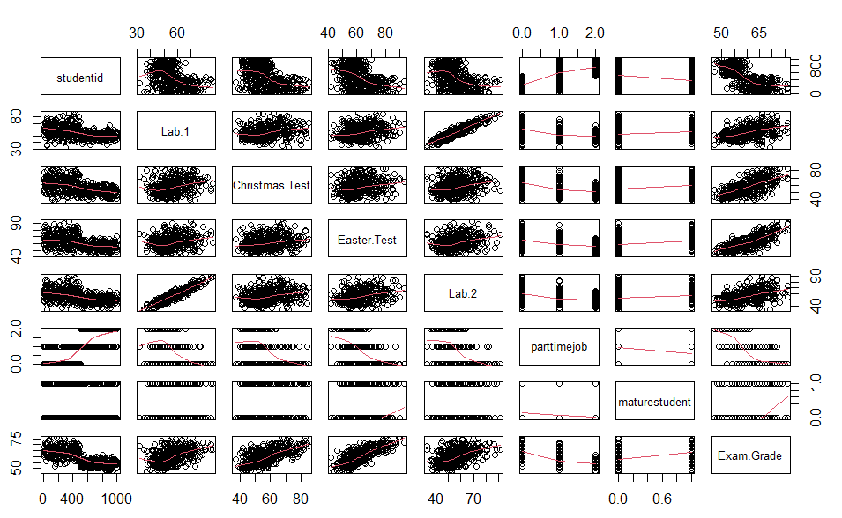
From this, we can see that the scores of the students generally stayed the same from lab.1 to lab.2 as it is very linear. We also see that the exam grade is higher for students who have a lower student number. We see that there is very little relationship between Christmas Test and lab 1, Easter test, and lab 2.

(b)
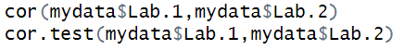
This code produced this output:
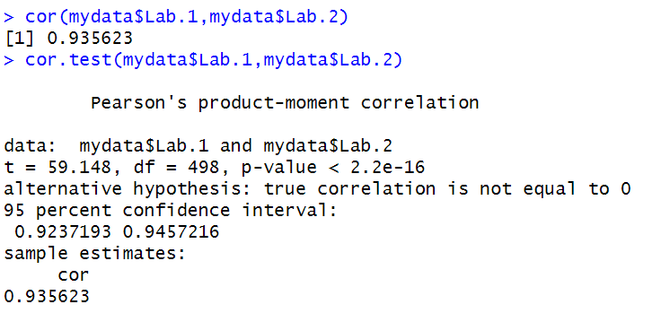
This means that generally, the result the student had in Lab 1 is very similar to the score that they got in Lab 2. It has a very strong correlation.

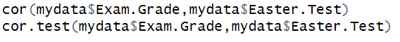
This code produced this output:
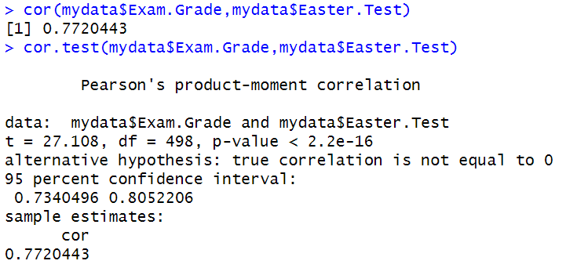
This shows that the Exam Grade is going up with the score the student got in their Easter Test. It has a strong correlation.

This code produced this output:
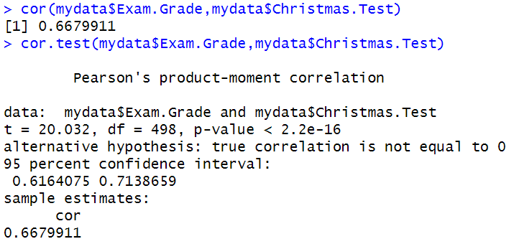
This shows that the Exam Grade is going up with the score the student got in their Christmas Test, although the correlation is slightly less than the Easter Test.

This code produces this output:
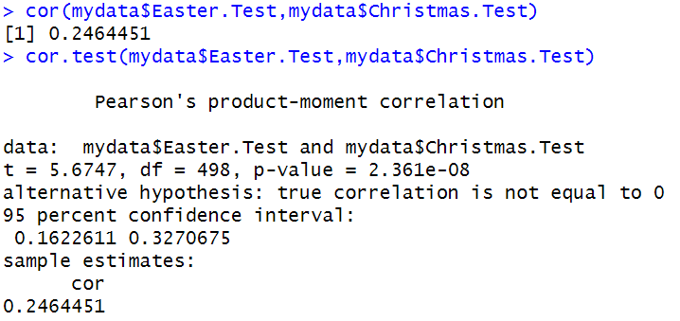
This shows us that the relationship between the Christmas Test score and the Easter Test score is very small as the correlation is only 0.2.

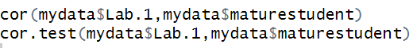
This code produces this output:
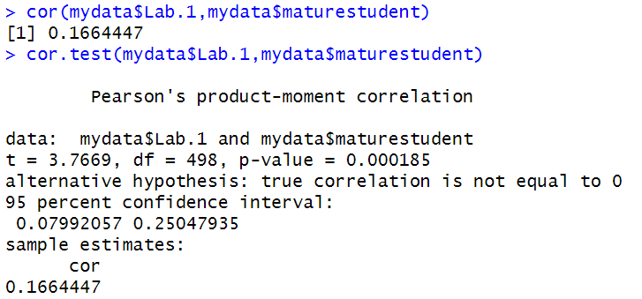
This shows that the score in Lab 1 has very little dependence on if the student is mature. The correlation shows that there is no relationship to very little between them.

(c)
This code produces this output:
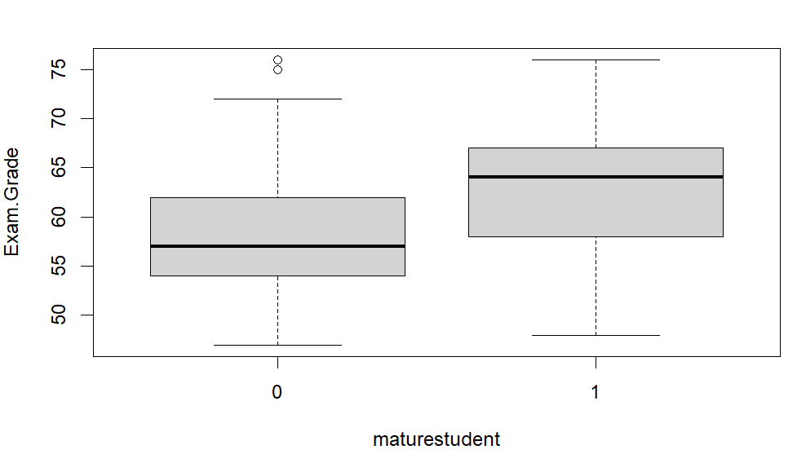
We can see that the mature students have a higher average than the non-mature students.

This code produces this output:
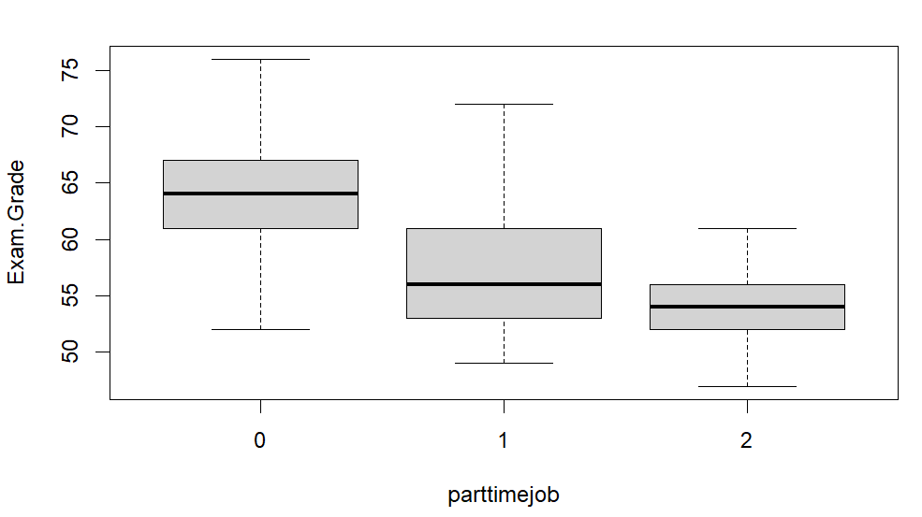
We can see that the average score of a student without a part time job is higher than the average of one with a job at weekends and that students with week-long part time jobs are have the lowest score on average.

Q2
(a)
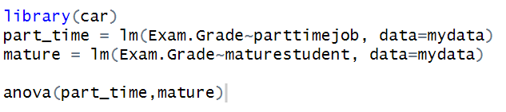
This code produces this output:
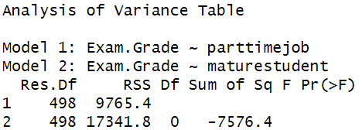
(b)
The terms that I would include in this model would be Mature Student, Christmas Test, Easter Test, Lab.1 and Lab.2, and Part time job as these terms have large coefficients. I would leave out the student id as this term has a very small coefficient.
(c)
This code produces this output:
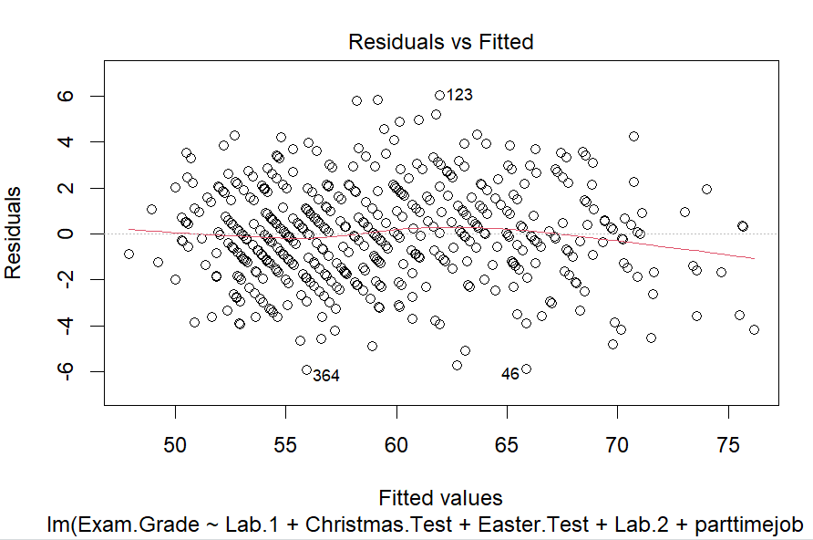
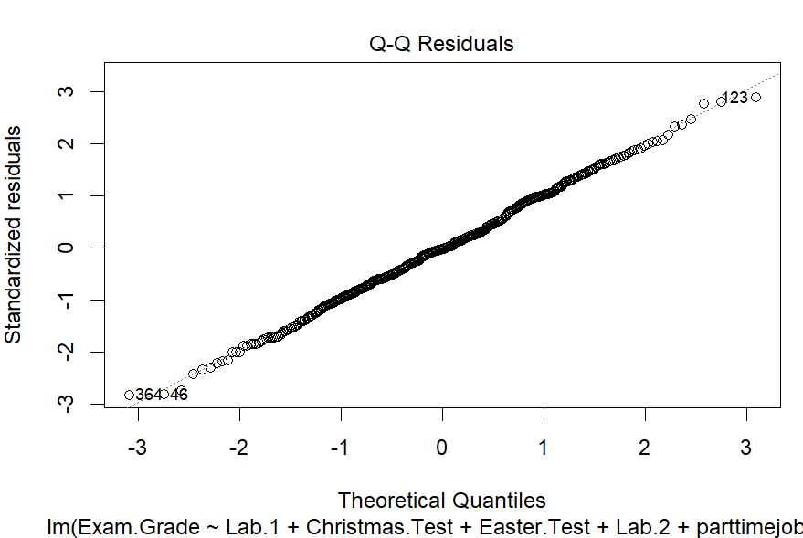
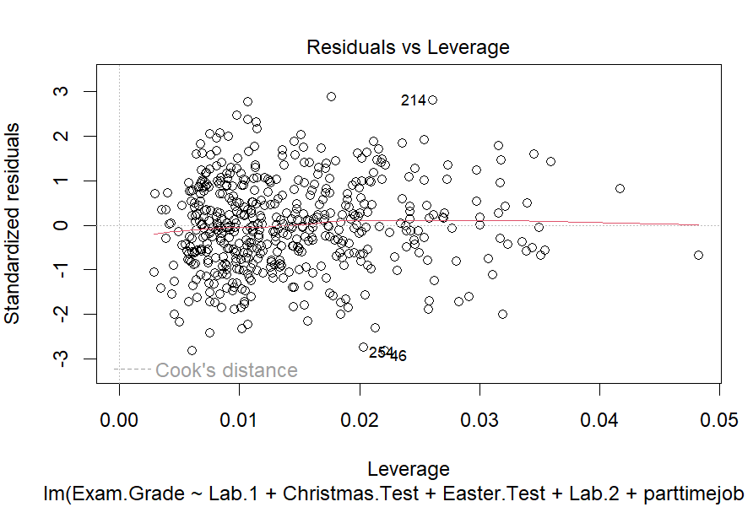
These results show that my assumptions are met as the graphs look correct.

Q3
(a)
I am happy with the fit of my model but I feel like it could be improved if I removed the lab1 and lab2 terms.
(b)
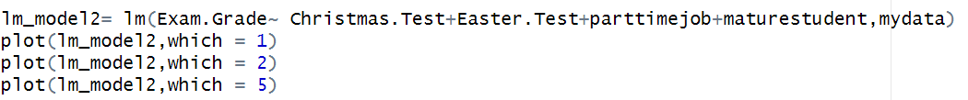
This code produces this output:
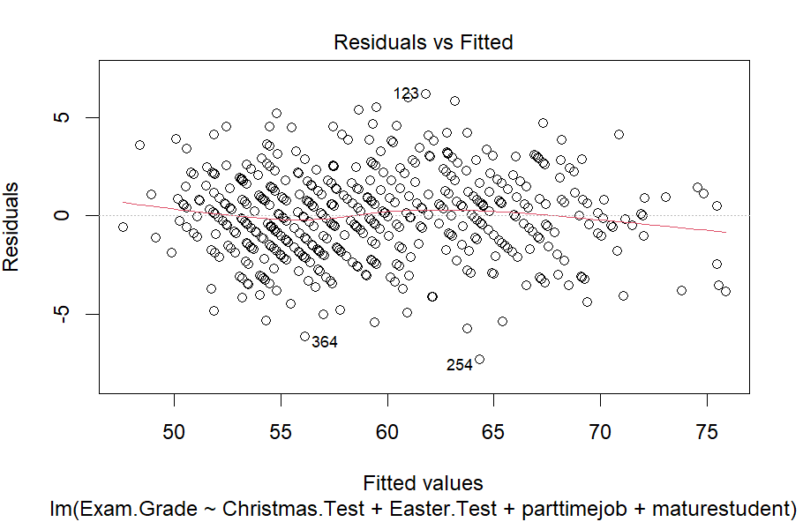
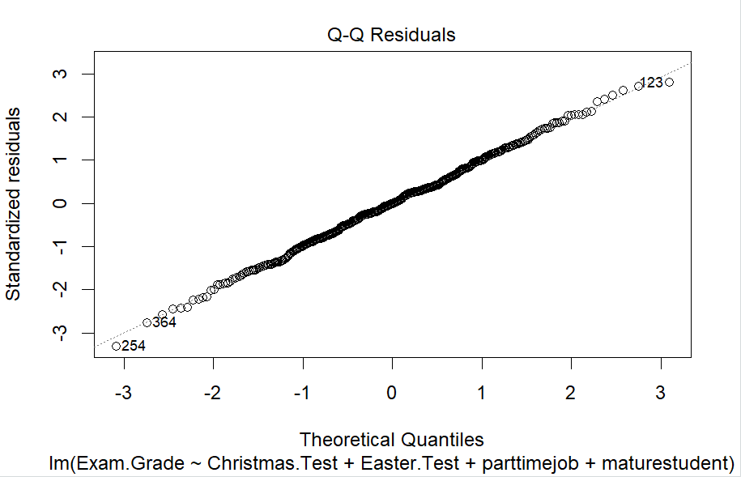
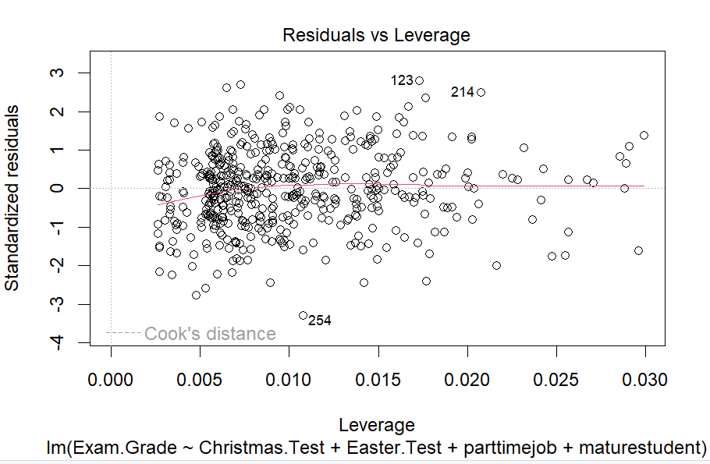
I am happier with this model as it meets the assumptions better than the first model did. I removed the lab1 and lab2 terms to create this model.
(c)
From this code I got:
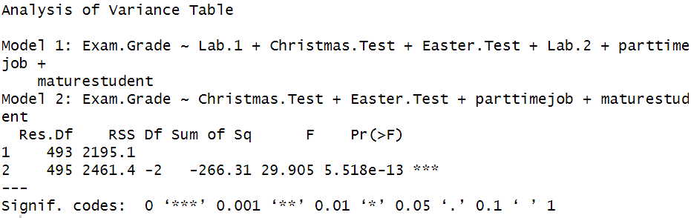

From this code I got:
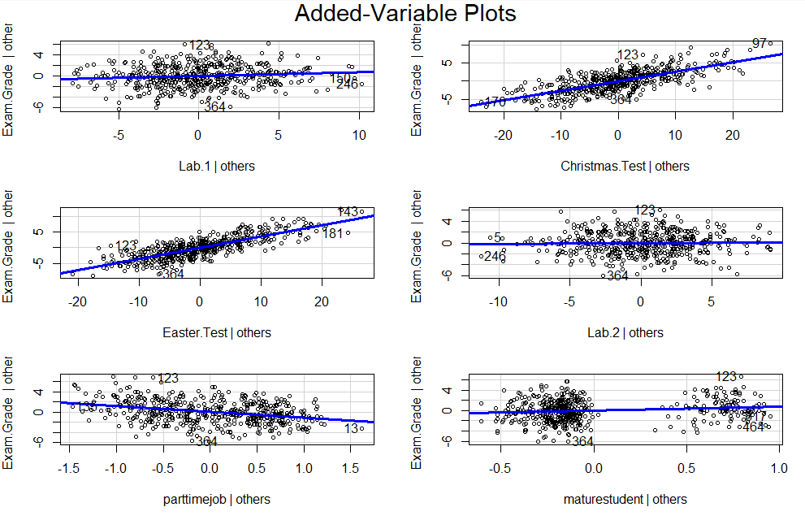
From this code I got:
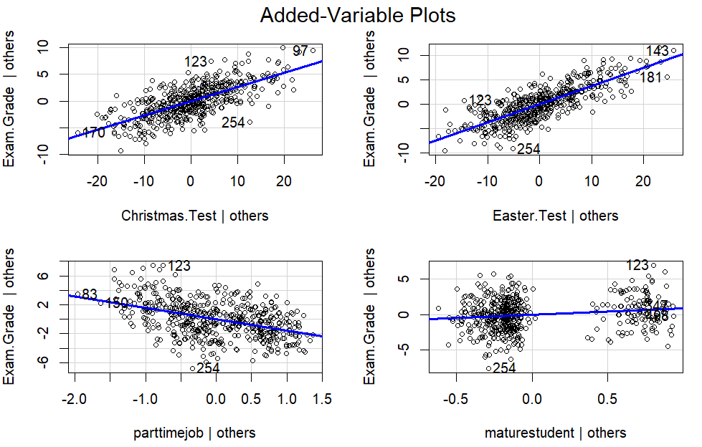

From this code I got:
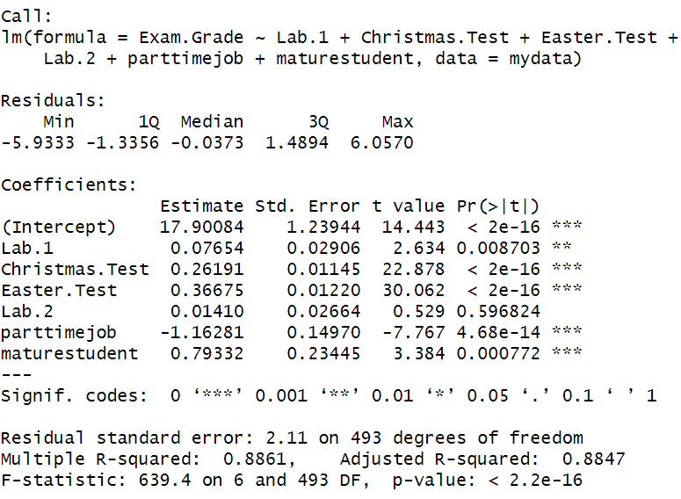
From this code I got:
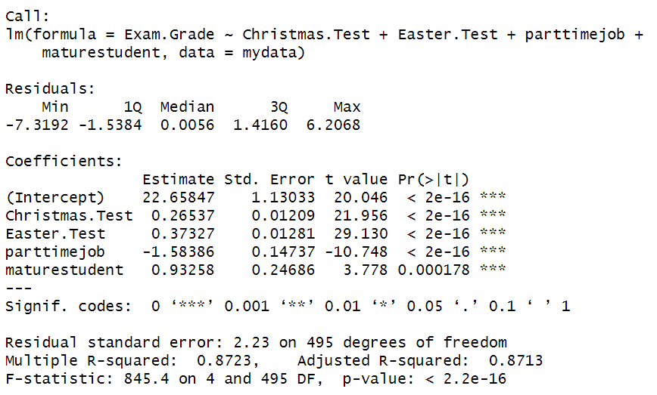
from this code I got:
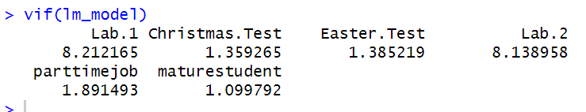
From this code I got:
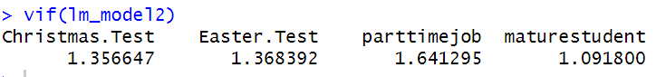
(d)
